**DESIGN DOCUMENT**

Created by: Jian Xian, Marshall Chang, Tina Do

**\*\*\*\*\*\*\*\*\*\*\*\*\*\*\*CANNOT EXCEED 4 Pages: please edit as needed -Tina**

**The design document should include**

1. **a general overview of your system with a small user guide**

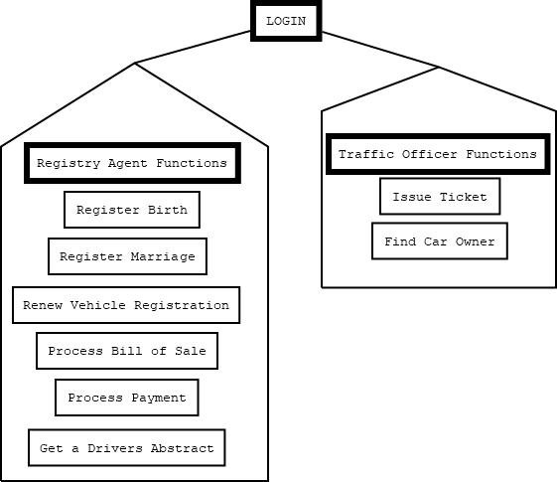

Our system is created using python code which allows for registry agents and traffic officers to update and make changes to the enterprise data in a database. The user should be able to login and select functions specific to the role of the user. See Figure 1 for general functions for Registry Agent sand Traffic Officers.

Figure - General Overview of system

1. **a detailed design of your software with a focus on the components required to deliver the major functions of your application**

Login:

System Functionalities

Registry Agents

Traffic Officer

**(c) your testing strategy**

**(d) your group work break-down strategy**

**Design Document** – Jian Xian, Marshall Cheng, Tina Do

**Graphical User Interface** – Marshall Cheng, Tina Do

**Interface** – Marshall Cheng

**Functionalities**

Registry Agent

1. Register a Birth
2. Register a Marriage
3. Renew a Vehicle Registration
4. Process a bill of sale
5. Process a payment
6. Get a driver abstract

Traffic Officers

1. Issue a ticket
2. Find a car owner

**Database** – Tina Do

**Testing** – Jian Xian, Marshall Cheng, Tina Do

The general overview of the system gives a high level introduction and may include a diagram showing the flow of data between different components; this can be useful for both users and developers of your application. The detailed design of your software should describe the responsibility and interface of each primary function or class (not secondary utility functions/classes) and the structure and relationships among them. Depending on the programming language being used, you may have methods, functions or classes. The testing strategy discusses your general strategy for testing, with the scenarios being tested, the coverage of your test cases and (if applicable) some statistics on the number of bugs found and the nature of those bugs. The group work strategy must list the break-down of the work items among partners, both the time spent (an estimate) and the progress made by each partner, and your method of coordination to keep the project on track. The design document should also include a documentation of any decision you have made which is not in the project specification or any coding you have done beyond or different from what is required.